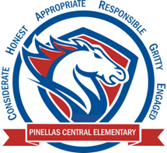

**Pinellas Central Elementary School**

**PreK School Supply List 2024-2025**

**Student Items (for individual student use)**

* full sized backpack-no rolling backpacks or mini backpacks
* extra change of clothes including underwear and socks in a large plastic zipper bag labeled with your child’s name
* small blanket and a standard fitted (the ones with elastic corners) crib size sheet for the cot for rest time.
* reusable shopping bag, labeled with child’s name – used for cot sheets
* refillable sports bottle with your child’s name on it
* clearview 1 inch 3 ring binder (clear pocket on front of binder)

**Supplemental Classroom Items-Donations Welcome**

* paper towels
* tissues
* baby wipes
* hand sanitizer
* disinfecting wipes
* play-dough
* dry erase markers
* zip top bag – sandwich, quart, gallon
* 3 oz paper cups
* paper plates – please no Styrofoam
* paper bowls – please no styrofoam
* craft supplies – googly eyes, pipe cleaners, beads, pom poms, etc.
* **healthy items** for snack time: pretzels, goldfish crackers, raisins, graham crackers, and animal crackers.